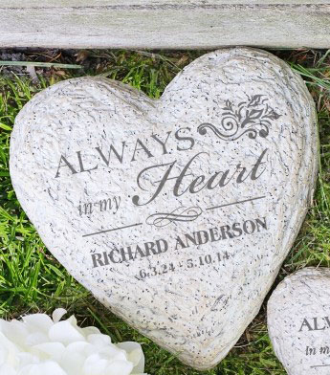
Playbook to Heal the Undercurrent of Grief and Loss
Unhealed Wound Seed

Creating a Memorial to Honor Grandmother’s Memory​
​

Who:​
- Culley, Mom, Dad, Haley, and Keenan​
​
What:​
- Each person will select a smooth, flat rock from the local rock quarry to paint their fondest memory of grandmother on it
- The rocks will be placed around the bench in the backyard​ to serve as a reminder of everyone’s fondest memories and love for grandmother
​
When:​
- Everyone will meet next Saturday morning at the house to go together to the quarry to select their rocks
- Family will work together to make grandmother’s favorite meal to celebrate her life after the trip to the quarry and before the work begins to create the rocks
- After lunch, each person will work to create their memorial rock – using dad’s sander if needed, and painting what they want on their respective rock (rocks can include a favorite memory or special characteristic that describes grandmother)
​
Where:​
- Rock Quarry and at home
​
How:​
- Family will go to the Rock Quarry together next Saturday at 10am
- After each person selects his/her rock, they will all return to the house for a lunch to celebrate grandmother’s life. Everyone will pitch in to help prepare the lunch
  - The week before the trip to the quarry, each person will put in a jar a slip of paper on which they write what they think grandmother’s favorite meal was. Then, no later than Friday before the day they go to the quarry, Culley will randomly pull one slip of paper out of the jar and that will be the meal that they prepare on Saturday – the day they create their rocks.
  - Grandmother will make a run to the grocery story Friday evening to ensure that she has all the needed ingredients for the meal
- During the lunch meal, everyone will share a minimum of one favorite memory of grandmother
- After the rocks are all completed, the family will together arrange the rocks around the bench in the backyard
- This bench will now be considered a “safe and quiet” space for anyone in the family to come to in the future to enjoy the memories of grandmother and/or to experience peace and serenity

