Playbook to Inject the Healthy Undercurrent of Attachment
Unmet Primal Need Seed

A Message from “The Fresh Prince of Bel Air”
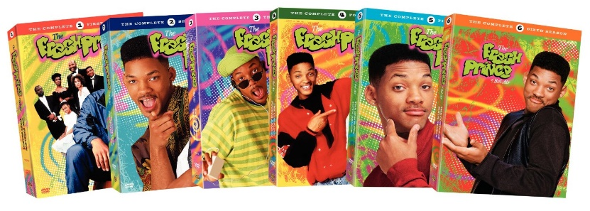
​

​

Who:​ James, mom, grandma

What:​
- Watch a selected clip from the popular television show “The Fresh Prince of Bel Air”
- Together, find the answers to the following questions:
  - What emotions did Will experience in response to being abandoned again by his father?
  - What emotion was at the core?
  - What was symbolic about the gift that Will was going to give his father?
  - How do you think this gift reflected Will’s heart toward his father, even after he abandoned him as a child?
  - Do you think Will’s abandonment wound will heal over time if nothing is done to repair it?

When:​
- Next Tuesday during your family therapy session

Where:​
- In the therapist’s office
​
How:​
- Find the selected clip on YouTube – titled “How come he don’t want me?”
- Watch the clip together and discuss the questions above
- Discuss what action steps would be helpful that will “tend” to the abandonment wound in James in order for it to heal over time.
- Co-create a second playbook with these key ingredients of the playbook: elements for security, safety, and emotional regulation

Therapist’s Guide for this Playbook

Suggested Viewers:
- Families who have children who have been adopted or have been in foster care.
- Families who have children who have been abused, abandoned or neglected.
- Families who have unhealed wounds that are triggering behavior problems in the children.
Script for Setting up the Scene:
- Will Smith stars as a teenager from inner city Philadelphia. Will’s father, Lou, abandoned him and his mom when he was 5 years old. When Will enters adolescence he starts making so many bad choices that his mom sends him to live with his Aunt and Uncle in hopes that they will be able to straighten him out.
In this scene you will see….
- Will’s dad, Lou, returns for the first time since abandoning Will as a young boy. After spending some time catching up with his son and planning a vacation with him, Lou makes excuses as to why he can’t take Will with him and why he may not be coming back for a while. In this scene you will see Will blowing off steam to his Uncle Phil in response to the deep disappointment he feels with his father as Will is abandoned once again.
Look for….
- The range of emotions Will displays while his childhood abandonment wound gets more deeply injured.
Play Selected Scene: Clip is found on YouTube entitled “How come he don’t want me?”

Discussion Questions:
- What were the range of emotions that Will displayed in response to being abandoned again by his father? What one emotion was at the core?
- What was symbolic about the gift that Will was going to give his father? How do you think this gift reflected Will’s heart toward his father, even after he abandoned him as a child?
- Do you think Will’s abandonment wound will heal over time if nothing is done to repair it?
Main Lessons:
- Emotional pain hurts and requires healing just as much as physical pain.
- Time does not heal all wounds. Wounds need to be tended to in order to heal.
- It is impossible for wounds to heal while enduring re-occurring blows.
- Often times the intense pain and sadness that a wound produces is masked by anger.
- A person never outgrows the need to be loved and accepted by their family members.

