Playbook to Manage the Unhealthy Undercurrent of Chemical Imbalance
Mental/Physical Impairment Seed

Medication Compliance Plan
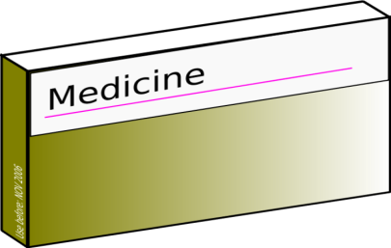

Who:
- The PLL Therapist, PLL Case Manager, mom and youth

What:
- Taking medications as prescribed by doctor to help with symptoms of anxiety

When:
- Take medications with breakfast and dinner – before 8am and between 7 and 8pm

Where:
- In the dining room at home

How:
- Youth will set a reminder on his cell phone for the morning dosage and the night dosage
- Youth will send a one line message to mom as soon as dosage is taken saying: “Meds taken”
- If mom does not get the text message 15 minutes after the designated time, she will text youth a reminder.
- Mom will check the bottle of medication at nighttime to ensure that the dosage was taken
- Mom will then place a check mark on the calendar on the fridge for successful completion of task.
- If youth forgets a dosage, he will wait for the next scheduled dose. MUST text mom to inform her.
- If youth has taken all his meds at the correct times Sunday to Friday as evidenced by the calendar on the fridge – mom will treat youth to his favorite dessert on Friday night or rent a Netflix movie for him (must be approved by youth).
- Both PLL therapist and Case manager will check in with mom and youth respectively mid-week to troubleshoot any hurdles and/or praise for compliance with plan.

