Playbook to Inject the Healthy Undercurrent of Structure, Education and Support
Mental or Physical Impairment Seed

Daily Hygiene Plan

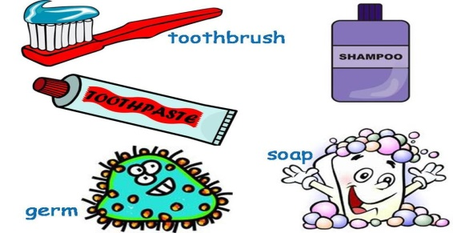

Who:
- Mom, youth, Aunt Kathy, John (Big Brother/Mentor)

What:
- Shower or take a bath using soap/body wash, shampoo and conditioner. Youth can have one “day off” per week on Saturday or Sunday.
- Brush teeth twice daily, once in the morning and once before bed. Youth will brush his teeth in front of an adult to get credit for it.
- Put on clean clothes each morning including undergarments.
- Brush hair: before school on school days; when he gets up on weekends; before he leaves the house; by 10am during summer holidays

When:
- This routine must be completed EVERY DAY.

Where:
- All of these activities must be completed at home – in youth’s bedroom and youth’s bathroom

How:
- Mom will be present when youth starts brushing his teeth
- For the first week, mom will assist by placing clean clothes and undergarments on the dresser in youth’s bedroom every night before bed
- Mom, with youth, will put a smiley face on the daily activity log for each completed activity (use log on next page)
- Aunt Kathy will text youth once per day with words of encouragement (mom will read the text aloud for youth from her cell phone)
- John will take youth on a special outing once each weekend for 1 hour
- Mom and Aunt Kathy will take youth to see a movie at the Dollar Theater on Sunday to demonstrate their love and support for youth. If he is compliant with his daily routine for that week, Aunt Kathy will buy him his favorite movie theater snack.
Daily Hygiene Activity Log

Week | Activity | Monday | Tuesday | Wednesday | Thursday | Friday | Weekend
Week 1 | Proper Shower or Bath
 | Brush Teeth 2x
 | Dressed properly
 | Brushed Hair
Week 2 | Proper Shower or Bath
 | Brush Teeth 2x
 | Dressed properly
 | Brushed Hair
Week 3 | Proper Shower or Bath
 | Brush Teeth 2x
 | Dressed properly
 | Brushed Hair
Week 4 | Proper Shower or Bath
 | Brush Teeth 2x
 | Dressed properly
 | Brushed Hair

