Playbook to Inject the Healthy Undercurrent of Structure, Education and Support
Mental or Physical Impairment Seed
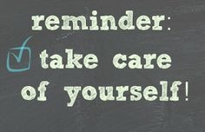

Self-Care Plan

Who:
- Mom, uncle, youth, PLL therapist

What:
- Encourage Youth to practice Self Care on daily basis

When:
- Every day

Where:
- At home

How:
- Youth will perform 1 task from each of the following categories:
  - Mental Self Care:
    - Read a Book
    - Write in journal
    - Call a friend
  - Emotional Self Care
    - Take a long relaxing hot bath
    - Listen to some soothing music
    - Help mom prepare dinner
    - Draw a picture
  - Physical Self Care:
    - Sit on the porch and eat some fruit
    - Go for a long walk
    - Go on the exercise bike
- Uncle will check in with youth every day to assist with the physical self-care and complete this task with youth
- Mom will check in with youth before 6pm to assess his progress with the tasks and assist him with them if necessary.
- PLL therapist will text youth twice per week with an encouraging text or words of support.
- Mom will sit with youth every night for 10 minutes and reflect on all the positives for the day or even just positive memories of their life together.

