Playbook to Heal Undercurrent of Physical or Mental Abuse
Unhealed Wound Seed

The Non-Violence Pledge
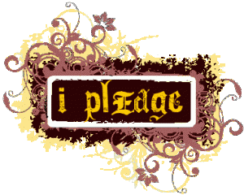
Who:
- Jeremy; Grandma and Grandpa; best friend-Tommy; and PLL Therapist

What:
- Jeremy will write an “anti-violence” contract to self to pledge his commitment to a lifetime of kindness toward self and others.
- Jeremy will hang his anti-violence pledge in his room as a symbol of his commitment to a lifetime of kindness toward self and others.
- The PLL Therapist will discuss relapse prevention, at the end of the session, and specific “red flags” (symptoms) to watch out for as evidence that he is beginning to forget about his pledge.
- Jeremy and Tommy will identify specific acts of kindness that they are both willing to commit to doing as ongoing antivenin to violence.

When:
- Next Session- Monday, October 26th at 6 PM

Where:
- In the home

How:
- Grandparents will provide a frame for the pledge.
- Jeremy will recite his pledge in front of his grandparents and his best friend.
- The specific acts of kindness will be decided upon and a plan of action will be implemented in session.

