Playbook to Inject the Healthy Undercurrent of Balance into the Family
Unmet Primal Need Seed
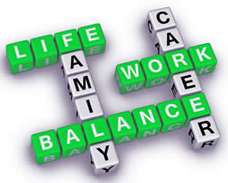
Our Family “Life Balance” Plan
As a family, we realize that we have become out of balance in the following areas: time spent together, health & exercise, and work. As a result, we will all commit to the following activities to restore balance to our family.

Who:
- Our Family (Mom, Dad, John, Cindy)

What:
- We will all commit to the following “rebalancing” activities:
- Family Home Evening (FHE) – everyone will stay home to do something together one night a week
- “Green Eggs and Ham” Breakfast
- Evening Walk

When:
- Family Home Evening will occur each Monday night
- “Green Eggs and Ham” is a special family breakfast that will occur every other Saturday or Sunday
- Our Evening Walk will occur 3 times a week (twice during the week and once on the weekend)

Where:
- At home and around the block (for the Evening Walk)

How:
- Our Family Home Evening (FHE) will include a fun family activity (selected from the list below) and is capped off with a special treat, prepared by Mom and Cindy. Everyone commits to staying home the entire evening, even after the activity has concluded. No one will go to their bedrooms until after 9pm. **The FHE Activity List can be added to with parental approval
- “Green Eggs and Ham” will be prepared by Dad and John and will either be pancakes, cinnamon rolls or a surprise specialty that Dad and John prepare together
- Our Evening Walk will include 2 times around the block to get some fresh air and share about the day’s events.

FHE Activities List
- Play a Family Game
- Play Charades
- Make Your Own Mini Pizza Party
- Have an Upside Down Backyard Picnic (everyone brings a whacky food item but must commit to eating their item along with the others)
- Make a Family Collage

