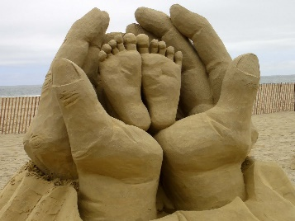
Playbook to Inject the Healthy Undercurrent of Forgiveness
Unhealed Wound Seed

Family Sculpture

A family sculpture is an arrangement of people or objects that is meant to visually symbolize the hurt and pain the wound has caused and led to unforgiveness. The major advantage of this sculpting exercise is its ability to cut through excessive verbalization, defensiveness, and projection of blame. The family is deprived of their familiar verbal cues and forced to communicate with one another on a different and spontaneous level.

Sculpting Enactment:

Who:
- The PLL Therapist and family

What:
- Follow the steps below to sculpt the family

When:
- Do the Sculpting Enactment during the session

Where:
- The Sculpting Enactment is conducted in the therapist’s office

How:
- Steps to complete the sculpting exercise:
  - #1- The therapist explains to the family that it is often easier to act out what is happening than just talking about it. Everyone in the room can show his or her own version of how they see the problem of unforgiveness and bitterness. After one person sculpts the family, each person can indicate their agreement or can show how they think the situation really is.
  - #2- Once the general overview is given, the therapist should make the following statement to the person selected to do the sculpting: “Imagine that you are a sculptor. I want you to make a sculpture of your family. Pretend your family is made out of clay. You can place them anywhere or in any position. Situate each person with each other or in relation to the arrow (hold it up) that shows how unforgiveness is poisoning your family right now”. (Have a plastic or practice arrow in the room to be used as the prop in the sculpting exercise. The Arrow represents the “wound”)
  - #3- After the first sculpture is completed, each person is given the opportunity to change the sculpture in any way that portrays how they are experiencing the unforgiveness in the family.
  - #4- After the sculptures are completed; the therapist asks the following questions:
    - Of the sculptor - Can you imagine that each person has a thought bubble over their head like the comic book characters? What does each bubble say?
- Of each other person - How does it feel to be in this place in this family and in relation to the arrow?
- Of each other person - Did you know that the sculptor perceived you or your role in keeping the unforgiveness going in this way?
- Of everyone, including the sculpture - Do you agree that this is how this family functions?
  - #5- Now ask the family to work together to reposition everyone to show what it would look like if forgiveness entered into the family
- The remaining time in the session is spent working with the family to determine steps to take to ensure that the new sculpture becomes the “norm” and that forgiveness will indeed enter into the family. This may be a second playbook.

