Playbook to Inject the Healthy Undercurrents of Unconditional Love and Nurturance
Unhealed Wound Seed

Cups and Self-Worth
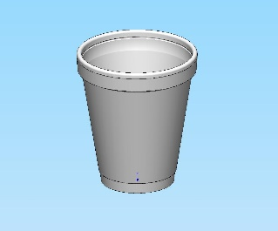

The use of a concrete representation of such an abstract concept as “Self-Worth” has many advantages. It serves to externalize an abstract concept, also it will serve as a reminder to the family long after the session by having them take the cups home to serve as a reminder and a reinforcement of the insights gained in the session.

Enactment:

Who:
- The PLL Therapist and family

What:
- Use a Styrofoam cup to move the family toward contemplation regarding behavioral changes to promote healthy interactional patterns
- Supplies needed – two Styrofoam cups and a bottle of water

When:
- Do the Styrofoam cup enactment in session

Where:
- Enactment conducted in the therapist’s office

How:
- Present a Styrofoam cup to the most wounded member of the family with the following script:
- “Suppose that this cup represents someone’s view of their self-worth. For example, if this person sees himself/herself as having good self-work, the cup is more or less intact, like this one. That way, when I pour water into it (pour water in the cup) it stays. In other words, when this person receives compliments or acts of kindness and affection, she takes them in, and holds onto them, and is strengthened by them for a good long while.
- However, watch carefully what happens when I pour water into a cup that has holes in it (poke holes in various places in a second cup, including a hole in the bottom of the cup, making the water drain out).
- You see, as long as water is flowing through the cup, even if it does not stay, the person feels like they are filled, or fulfilled. However, as soon as I stop pouring water in, the cup runs dry very quickly. Do you see where I am going with this?

- The goal is to help the client to realize that she is like the second Styrofoam cup with the holes in it, constantly needing other people to tell her that she is a good person in order to feel that she has value as a person. Moreover, as soon as she is not getting compliments or when no one is showing her affection, she feels empty and worthless again.
- Point out that there are two problems with that situation. The first is that no matter how much attention or how many compliments a person might receive; it will never be enough because the cup has holes in it. Nothing stays inside.
- The second problem is that the cup erodes, a little like the ocean eroding the shoreline over time. The more the water runs through the cup, the bigger the holes get, and the more water it takes to have just a few drops in the cup at any given time.
- The remaining time in the session will be spent working with the client and the family to determine the steps to take to repair the holes in the cup. (i.e. a second playbook that will focus on providing security and unconditional love for the client)

