Playbook to Inject the Healthy Undercurrents of Unconditional Love and Nurturance
Unhealed Wound Seed

Helping Others Campaign
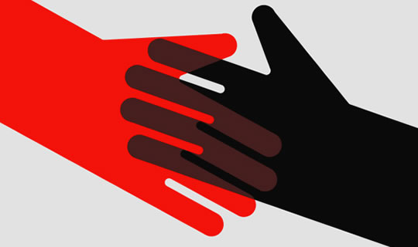
“When you help others you help yourself”. One of the best ways to heal is to take one’s mind off one’s own problems by helping others less fortunate.
Who:
- John and his mom

What:
- John will spend 8 hours a week helping those less fortunate than himself.

When:
- Tuesdays after school and Sunday afternoons

Where:
- Volunteer at the local homeless shelter, children’s hospital, animal shelter, or senior citizen’s home.

How:
- Mom will contact the director of each of these agencies and pre-screen their willingness to help.
- If there is an opening, John and PLL Coach will practice by role-playing what to say at the interview.
- John will go on the interview and start working
- After two weeks John and his mom will meet with the PLL Coach to talk about the experience and how helping others is changing how John feels about himself.

