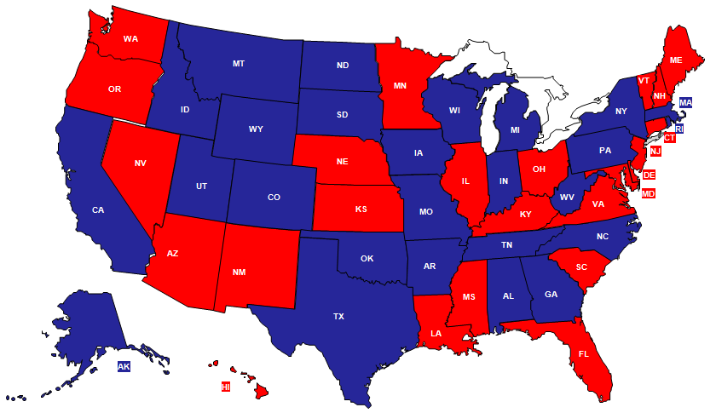
Blue State
Balanced Budget or Surplus- (North Dakota, Alaska, Montana, etc) or Deficit And Recognized Need to Cut Costs
High numbers of juveniles or youth in either residential or foster care
Service Provider already has a presence
High number of Private Providers
Lack of Entrenchment With Other Evidence-Based Models Such as MST or FFT

Red State
Severe Budget Deficits or Survival Mode Hinders Ability for Outside the Box Solutions
Low numbers of juveniles or youth in residential or foster care
No Service Provider have to start from ground zero
Low number of private providers
High entrenchment with other evidence-based models such as MST or FFT

Red and Blue States Defined

State by State Information 1
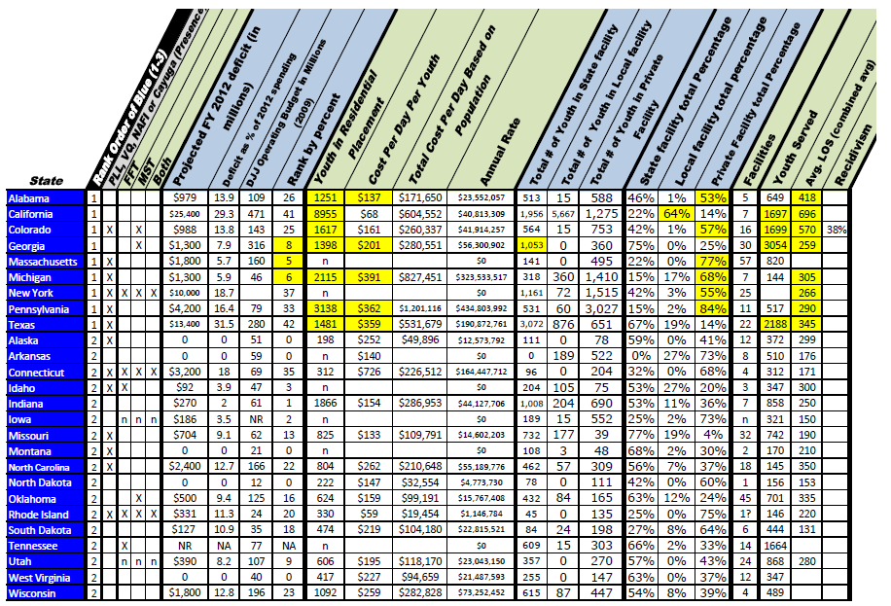

State by State Information 2
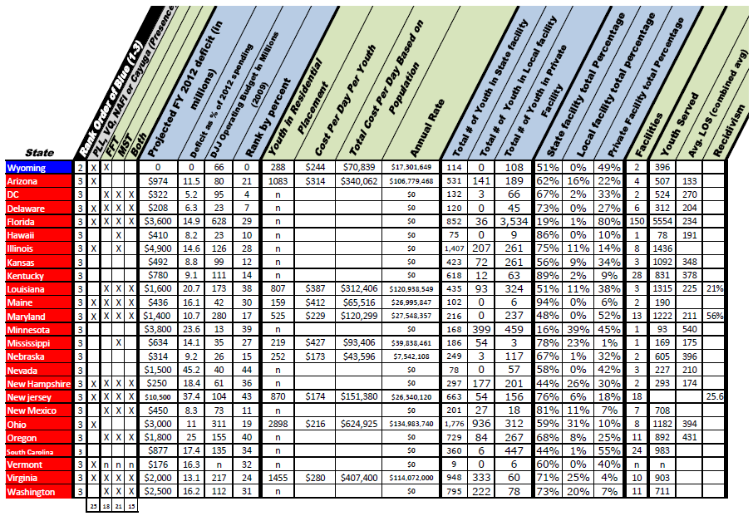

State by State Information Key
Key from left to right
Rank | Based on Blue Ocean and Red Ocean Definitions
PLL, VQ, NAFI, or Cayuga (Presence) | At least one of these agencies are currently providing services in these states
FFT | Functional Family Therapy
MST | Multisystemic Therapy
Both | Both FFT and MST combined
Projected FY 2012 deficit (in millions) | Projected short fill measured in millions
Deficit as % of 2011 spending | Percent of budget cuts needed to balance the state budget
DJJ Operating Budget in Millions 2009 | Budget taken from the CJCA Annual Publication
Rank by Percent | Percent from lowest (small percentage) to highest (Largest percentage) deficit
Youth in Residential Placement | Count of actual youth in system according to Justice Policy Institute May 2009
Cost per day per youth | Identified by Justice Policy Institute, State website, CJCA
Total Per youth Day Based on Population | Cost per day times the number of youth in residential facility
Annual Rate | Cost per day times number of youth in snapshot times 365 days
Total # of youth State Facility | Actual youth in State operated facilities (OJJDP)
Total # of youth in Local Facility | Actual number of youth in local (shelters type) facilities (OJJDP)
total # of youth Private Facility | Actual number of youth being served in Private provider facilities (OJJDP)
State Facility total Percentage | Percentage of youth served in State operated facilities (OJJDP)
Local Facility total percentage | Percentage of youth served in local (shelter type) facilities (OJJDP)
Private facility total parentage | Percentage of youth served in Private provider facilities (OJJDP)
Total # of Facilities | Actual number of physical facilities
Youth Served | Number of youth served
Avg. LOS (combined avg) | Taken from CJCA Annual Publication 2009 reported by state
Recidivism | *Different for each state

Current States with Existing Programming

Current States with Programming
PLL | NAFI | Vision Quest | Cayuga Homes
Alaska | Connecticut | Arizona | Ney York
Colorado | Florida | Delaware
Florida | Massachusetts | Florida
Idaho | Maryland | Maryland
Illinois | Maine | New Jersey
Michigan | New Hampshire | North Carolina
Montana | New York | Pennsylvania
Ohio | Rhode Island | Texas
Texas | Virginia
Virginia | Vermont
Wyoming
Netherlands
www.gopll.com | http://www.nafi.com/Default.aspx?title=Welcome | http://www.vq.com/index.php | http://www.cayugahome.org/

Residential Facilities Over/Under Capacity Chart

Prescreening Checklist (pages 1-2)
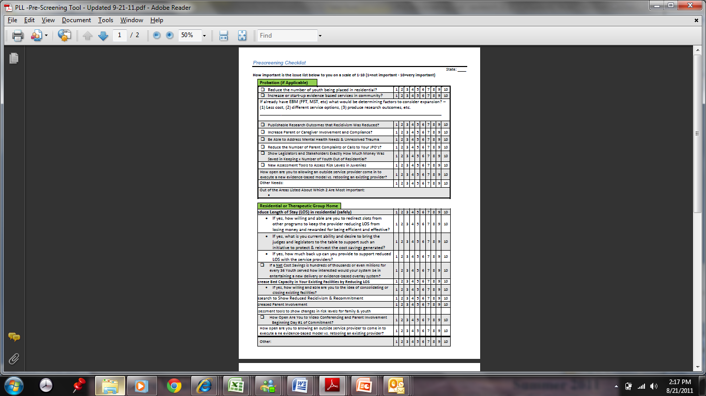
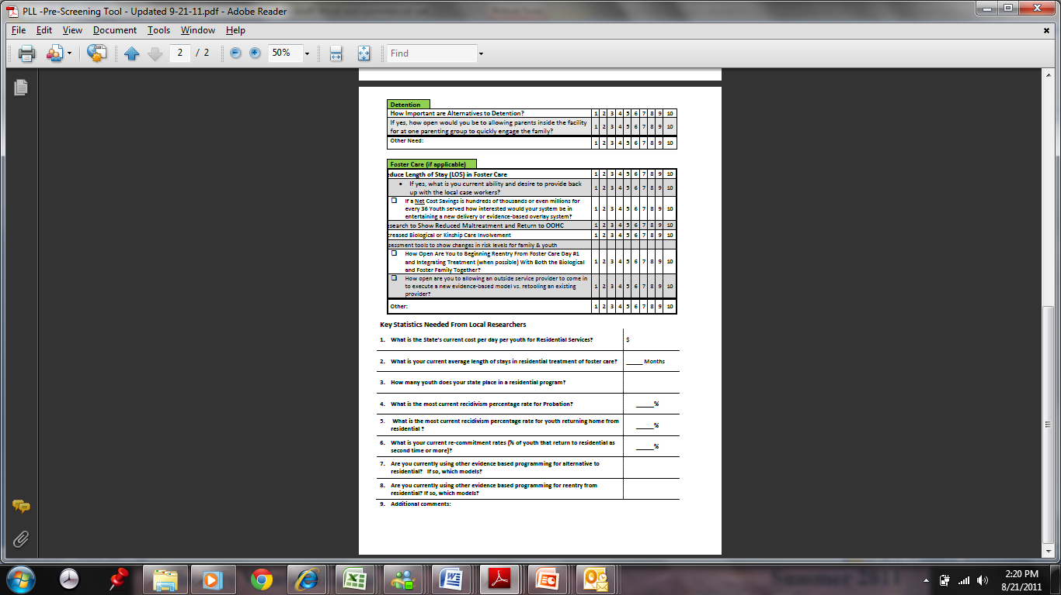

Ways to Go to Market with PLL Flowchart (Page 1)
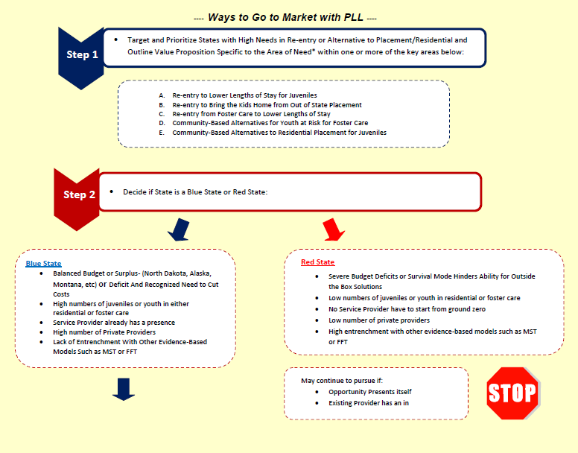

Ways to Go to Market with PLL Flowchart (Page 2)
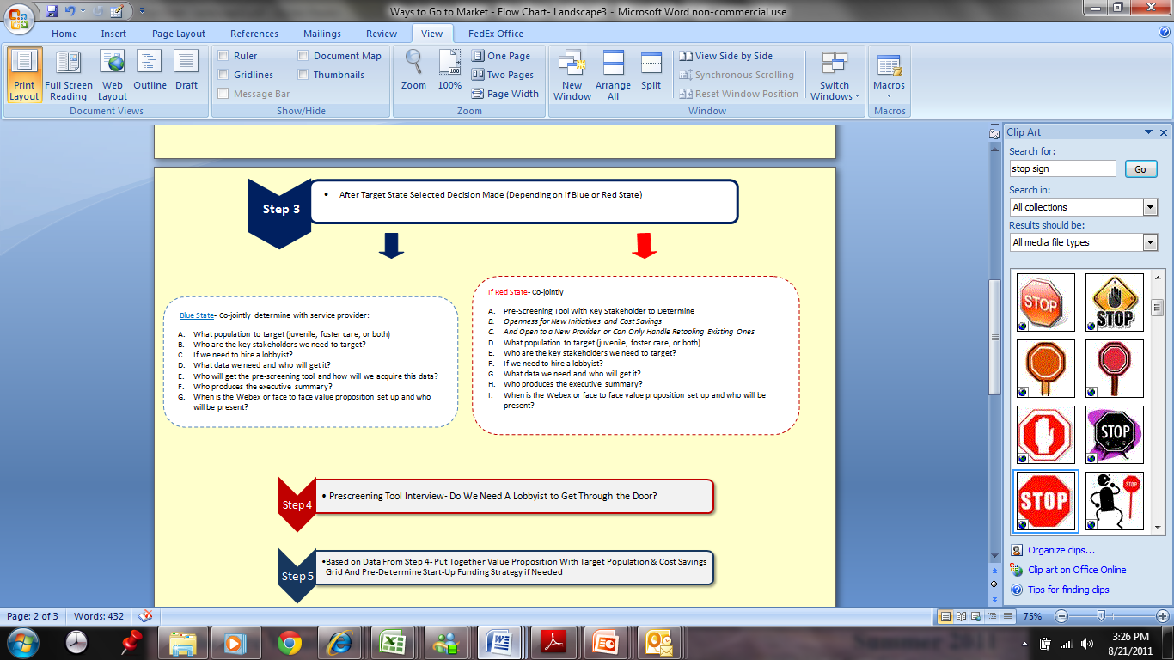

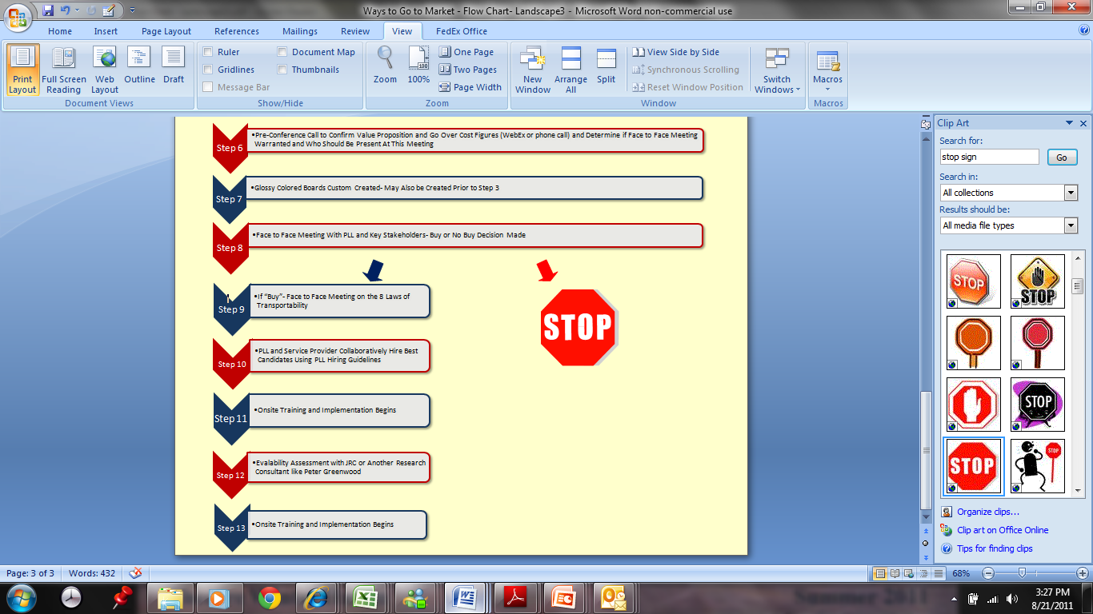
Ways to Go to Market with PLL Flowchart (Page 3)

PLL Dashboard - Overall Measures
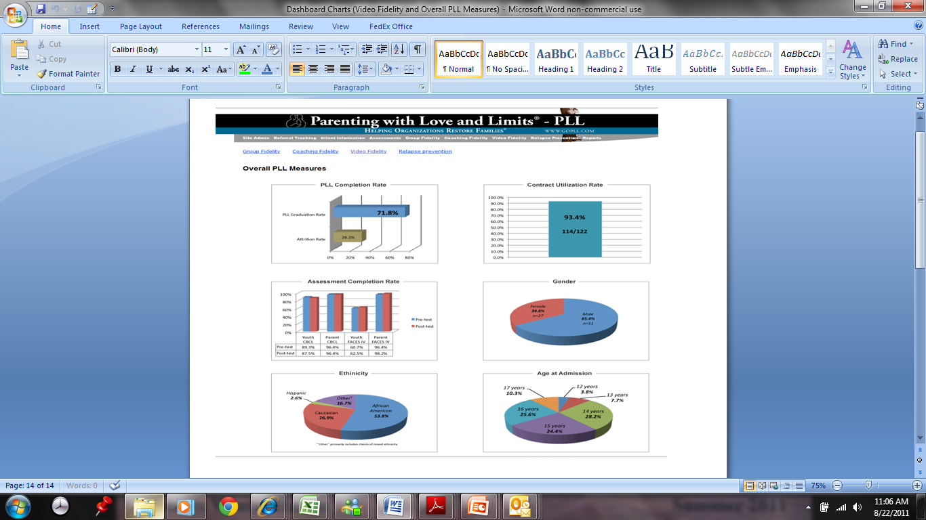

PLL Dashboard – Video Fidelity
