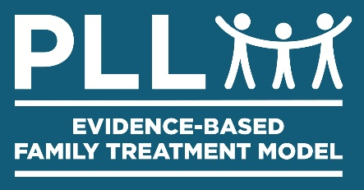
Community Based Action Team (CBAT)
Agenda

Date: ________________

Standing meeting every

______________

of the month at _____________________________ (Location)

Next Monthly Meeting: _______________

Cases to be discussed

- Youth: Click here to enter name (10 minutes)

- Youth: Click here to enter name (10 minutes)

- Youth: Click here to enter name (10 minutes)

- Youth: Click here to enter name (10 minutes)

- Youth: Click here to enter name (5 minutes)

- Youth: Click here to enter name (5 minutes)

Celebration of New Youth(s) Coming Home

- Youth and Family attend first CBAT meeting in person (if possible)

Prepared by PLL® Revised 10/15/19

