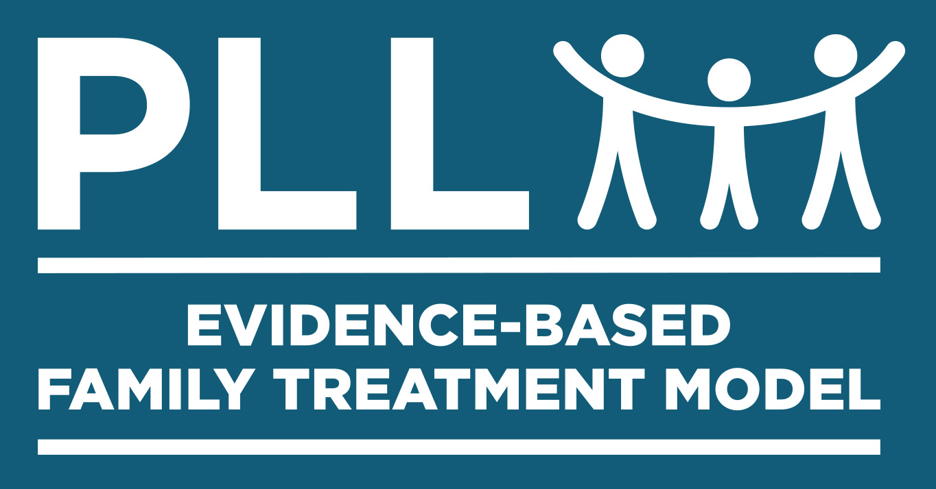
Community Based Action Team (CBAT)
- Case Manager's Agenda -
AGENDA
1. Open Meeting
2. Thank everyone for attending
3. Announce the meeting will only be 1 hour
4. Introductions (let everyone self-introduce)
5. Set Date, Time & Location for next Meeting
6. Select a time keeper (keep CM on time)
7. Make sure everyone has a CBAT Agenda
8. "Cases to be discussed"
- Ecomap
- Risks/Protective/Needs (RPN Doc.)
- Write Recommendations on RPN Doc.
9. Review Actions Steps identified by CBAT
10. Thank everyone again for attending
11. Close Meeting
Youth to discuss today

- J. S. – 10 min
- J. D. – 10 min
- B. R. – 10 min
- N. D. – 10 min
- G. M. – 5 min
- N. A. – 5 min

Monthly Meeting

Standing meeting every

______________
of the month at

_____________________________
Location.

PROCEDURES TO PREPARE FOR CBAT MEETING (PRIOR TO MEETING)
- Case Manager completes an Ecomap with the youth and guardian when they meet for the first time.
- The Ecomap will be used to inform CBAT members about potential helpers/villagers to assist
In meeting the needs of the youth and family.
- Discuss each youth with PLL Clinician to gather additional information prior to CBAT Meeting.
- Contact the (Case Worker, Probation Officer, DSS Worker, and OCS Worker) to discuss history of youth. If available, ask if there is a formal assessment tool; PACT, YASI, YLS, etc...
- Compile information gained from the Family, PLL Clinician, & Case Worker and document on the Risk, Protective Factors & Needs Document (RPN Document). Try to document specific factors (no general). This document will be used to inform CBAT members about the youth and the family.

DISCUSSION POINTS FOR CBAT MEETING (TO BE USED DURING MEETING)
- Case Manager provides brief summary (paint a picture) identifying Risk and Protective Factors and the Needs of the Family (RPN Document). Document Action Steps identified by CBAT members on the bottom of RPN.

- Discuss the Ecomap findings with CBAT team (discuss potential village members).

- If case has already been discussed in a prior meeting then bring CBAT team up to speed and describe any new developments (Success Stories/What is working because of the CBAT)

Celebration of New Youth(s) Coming Home
- Youth and Family attend first CBAT meeting after release back home in person (if possible).

