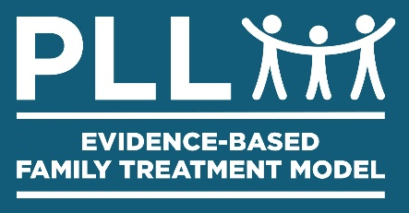

Community Based Action Team (CBAT)

- SAMPLE -
CBAT Team  - PLL Case Manager  - Probation Officer  - YMCA Representative  - Faith Community Representative  - Education  - Boys and Girls Club Representative  - Workforce Representative  - …  - _________________ | Youth and Specific Supporters/Helpers  Key-Blue-Potential Helpers that the CBAT Team identified  Black-Helpers who have already agreed to help
 | Youth: M. Jones  - Michael Jorden – Workforce Board | Youth: J. Dangerous  - Bart Simpson - Mentor
 | Youth: J Doe  - Uncle Howard Cunningham – Mentor for Mom  - Billy Graham – Youth Pastor | Youth: B. Bonds  - Joe Somebody – Salon Owner  - Bruce Almighty – YMCA Worker
 | Youth: K. Martin  - George McFly – McDonalds Manager  - Eddie Haskil – Big Brother Big Sister | Youth: L. Hartman  - Cindy Crawford – Close Family Friend  - Mary Tyler Moore – Small Business Owner
 | Youth: B. Colley  - Luke Skywalker – Mentor  - Forest Gump – Army Recuiter | Youth: R. Downs  - Bruce Willis – Community Center  - James Brown – Music store owner
 | Youth: | Youth:

NOTES:
Prepared by PLL® Revised 10/15/19

Community Based Action Team

- TEMPLATE -

CBAT Team  - PLL Case Manager  - ___________________  - ___________________  - ___________________  - ___________________  - ___________________  - ___________________  - ___________________  - ___________________ | Youth and Specific Supporters/Helpers  Key-Blue-Potential Helpers that the CBAT Team identified  Black-Helpers who have already agreed to help
 | Youth:  - …  - …  - … | Youth:  - …  - …  - …
 | Youth:  - …  - …  - … | Youth:  - …  - …  - …
 | Youth:  - …  - …  - … | Youth:  - …  - …  - …
 | Youth:  - …  - …  - … | Youth:  - …  - …  - …
 | Youth:  - …  - …  - … | Youth:  - …  - …  - …
 | Youth:  - …  - …  - … | Youth:  - …  - …  - …

