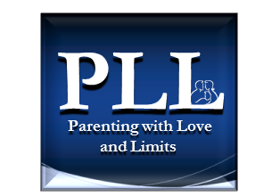****

CBAT TRAINING PHASES

Prepared by Parenting with Love and Limits® Revised 04/19/13



* **1st WebEx Meeting**

**Phase 1** – PLL presents overview of CBAT Process and Documents

* + - 1. CBAT Overview(1a) & Treatment Timeline(1b)
      2. Ecomap & Instructions (2a) & Blank Ecomap + Sample (2b)
      3. Risk and Protective Factors & Family Needs & Instructions
      4. Introduction to CBAT for Potential Members

*- Greetings from Community Based Action Team Reentry (4a)*

*- Greetings from Community Based Action Team ATP (4b)*

* + - 1. CBAT Meeting Agenda

*- For Case Managers Eyes Only (5a) & Handout for CBAT Attendees (5b)*

* + - 1. Community Based Action Teams (CBAT)

*- CBAT Sample (6a) / CBAT Template (6b) / CBAT Electronic Template (6c)*

* + - 1. Aftercare Plan Sample & Template
      2. CBAT Supervision Agenda (8)
      3. Corrections Today article “Juvenile Recidivism- Measuring Success or Failure”
* **2nd WebEx Meeting**

**Phase 2** – PLL demonstrates a CBAT team meeting with role plays

* **3rd WebEx Meeting**

**Phase 3** – PLL observes the new PLL Case Manager demonstrate a monthly CBAT

Team meeting with role plays and ancillary documents

* **Ongoing Monthly WebEx Supervision**

The PLL Supervisor begins to conduct monthly CBAT supervision

The PLL Supervisor reviews one video tape recording of a 1st or 2nd CBAT meeting

conducted by the PLL Case Manager. (Video may also be reviewed by PLL President and Clinical Director)