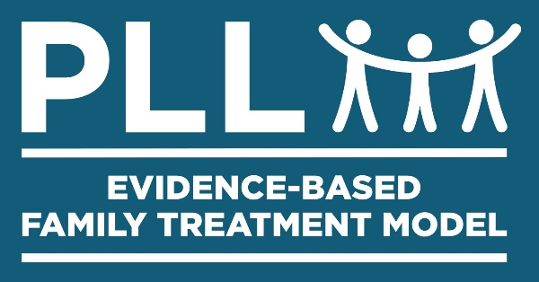
Ecomap

Instructions
- Draw a medium-sized circle in the center of a piece of paper. Place symbols for family members inside this circle. Ask each family member to choose a color that will be associated with that person. Use that color when drawing symbols and information connected to that person.

- Start with the parents. Connect their symbols using a straight line. Add children by connecting them with a line stemming from this connecting line. Draw squares to represent adults and circles for children. Write the person's name and age near his symbol.

- Ask family members individually about the environmental systems they interact with regularly. Give examples such as work, clubs, sports, friends, church, extended family and regular family activities. Explain that they should include the things they do most often, if they have difficulty narrowing down this list.

- Draw smaller circles outside of the middle circle to represent the named systems. Label these systems as appropriate -- for instance, "Mom's Work." Draw lines to represent the relationship that different family members have with this system. Use different types of lines to represent that relationship. For instance, a solid line represents a strong relationship and two solid lines together indicate a very strong relationship. A wavy line can be used for a strained relationship and a dotted line for a negative relationship
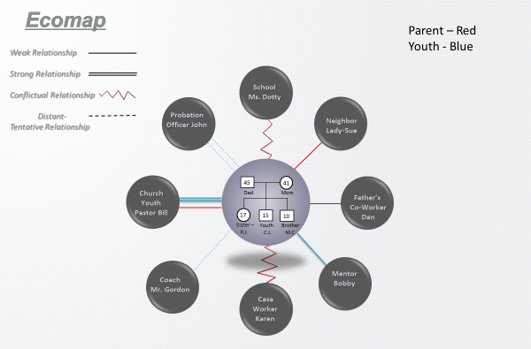

Prepared by Parenting with Love and Limits® Revised 05/10/13
Prepared by the Parenting with Love and Limits Development Team
Ecomap
Ecomap

Weak Relationship
Strong Relationship
Conflictual Relationship
Distant/Tentative Relationship - - - - - - - - - - -

Family
Prepared by Parenting with Love and Limits® Revised 05/10/13
Prepared by Parenting with Love and Limits® Development Team

