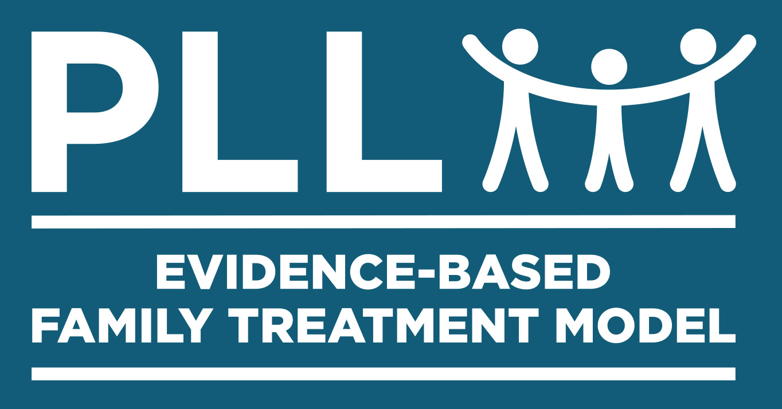
Informed Consent for PLL Family Systems Trauma

Your Agency Letterhead

This Informed Consent Form is for families who want to participate in PLL-FST (Family Systems Trauma) treatment. This Form is given now because we are about to begin active wound or trauma treatment with the introduction and completion of what are called "wound playbooks". Therefore, the optimal timing to go over this form is now to discuss both benefits and limitations of this approach for you individually and your family or village as a whole.

PART I: Introduction and Overall Purpose of PLL-FST Treatment

PLL-FST treatment was built to work with the entire family, not just your child or teen. This is because we believe that there is power in families to help heal one another. When one person in the family experiences a wound or traumatic event, everyone hurts. The PLL-FST treatment model was developed based on outcomes that your child can heal better and faster if everyone helps and changes.

Type of Intervention

- PLL-FST treatment was built on the belief that optimal change can happen best in the here and now. This means while we can learn from the past, we cannot change the past. But we can change the future. Therefore, we will talk about past hurts but then focus on the "now what?" What tools do we need in the here and now to heal our wounds and those of our child so we do not stay stuck in our pain? To answer this question, we will be creating together what are called "wound playbooks". (see sample playbook)

- As your counselor, I will actively help, give advice, and facilitate the creation of your playbook. But you and your child will be active participants as well and we will create your playbook together.

- After we create the playbook or playbooks, we will practice their delivery through role plays or dress rehearsals and troubleshoot any potential "what will you do if x, y, or z goes wrong?" ahead of time. We will then put the playbooks into action and afterward come together to evaluate how well it went and troubleshoot any problems in implementation. If there are problems, we will work together to tweak the playbook accordingly.

- After you complete the PLL-FST treatment, we will do "tune ups". This means that if you or your child relapses, which is normal, we can meet as needed for one or two sessions only to get back on track as quickly as possible.

PART II: List of Benefits and Limitations

Like many other trauma-focused treatments, PLL-FST treatment does not presently have clinical trials of effectiveness or FDA type approval. However, painstaking effort has gone into developing this model through research studies that show good outcomes on key components of the PLL-FST treatment model (c.f., Karam, Sterrett, & Kiaer, 2015; Sells, Winokur-Early, & Smith 2011; Winokur-Early, Chapman, & Hand, 2013).

Potential Benefits

- Step-by-Step Procedures: The PLL-FST treatment model provides your counselor with written step-by-step procedures. Many treatment models provide general concepts but not step-by-step procedures. These step-by-step procedures benefit you and your family because your counselor has a clear roadmap to follow and treatment that is standardized and based on good research study outcomes.

- The Whole Family and Village is Involved: Traditional trauma treatment has mostly involved just the individual child, without active participation from the entire family or the extended family or village. PLL-FST treatment is one of the first models ever to involve your entire family in helping heal you and your child's wounds.

- Skills and Playbooks- As illustrated in the playbook sample, you will leave PLL-FST treatment with written and concrete playbooks with clear tools and skills in the here and now to heal you and your child's wounds that have not healed on their own.

- An Active Coach to Help Guide the Process- You are not alone. As your counselor, I will function like a fitness coach to help guide the process and step in if there are relapses or setbacks. Wound work is hard if you have to go it alone. Now you will have a professional coach to support you throughout. Therefore, it you back away now, you will have to go it alone.

Potential Limitations

- It is Likely to Get Worse Before it Gets Better- Your child's present day problems may initially get worse before they get better because we are uncorking or reopening old and unhealed wounds. This is initially scary. The good news is that having a coach and a written playbook dramatically increases the odds that becoming worse is temporary on the way to permanent healing. You should expect the first 30 days to be the toughest. After 30 days, things usually get better and better.

- Talking About Wounds May Initially Reopen Them- Discussing unhealed wounds can cause one to become re-traumatized just by talking about it and cause what are called hypo or hyper reactions. This is why we built in self-regulation tools, nutrition, and safety planning into the PLL-FST treatment model.

- The "Walking Wounded" State is Challenged- Currently, you or your child might be in what is called a "walking wounded" state. This means that you currently have coping strategies (alcohol, prescription painkillers, self-harm, etc.) that don't heal the wound but just help you get through the day. Using PLL-FST treatment, we try to provide better coping strategies (self-regulation tools, playbooks, etc.) and get you to a place where the wound is permanently healed. But in the meantime, your stress may increase as these unhelpful coping strategies are addressed.

- Other Unanticipated Areas May Be Impacted- When we throw a pebble in a pond it creates ripples outward. In the same way, as we treat your child, other areas may be impacted as well. For example, if your child suddenly gets better after years and years of you taking care of him or her, it may shine the light on other problems that have been ignored until now. For example, parents may now face marital problems that had been ignored or other sibling resentments over the longstanding focus on the problem child while they felt ignored, or even a parent asking themselves what is my new identify now that my child no longer needs me.

PART III: Certificate of Consent

Your participation in PLL-FST treatment is entirely voluntary. It is your choice whether to participate or not. If you choose not to participate, we will refer you to other treatment options. If you begin PLL-FST treatment and change your mind later, you can stop participating even if you agree to participate today.

Typical Duration

From this point forward, PLL-FST treatment typically involves an average of 6 to 8 sessions. After graduation we will follow-up with you by phone at least once a month for the next 90 days to assess for any relapse. If relapse occurs, we will recommend what we call "tune-ups". These are one to several sessions to address relapse and get back on track as quickly as possible. Tune-ups are also voluntary.

Confidentiality

All counseling content is confidential. This means that no information is released to individuals outside the Counseling Service without signed consent. Exceptions to this rule, include threats of harm toward oneself or another person or court subpoena for records.

I have read the foregoing information, or it has been read to me. I have had the opportunity to ask questions about it and any questions that I have asked have been answered to my satisfaction. I consent voluntarily to participate in PLL-FST treatment.

Print Name of Each Family Member _____________________________________________________________

Signature of Each Family Member ______________________________________________________________

Date ___________________________
Day/month/year

