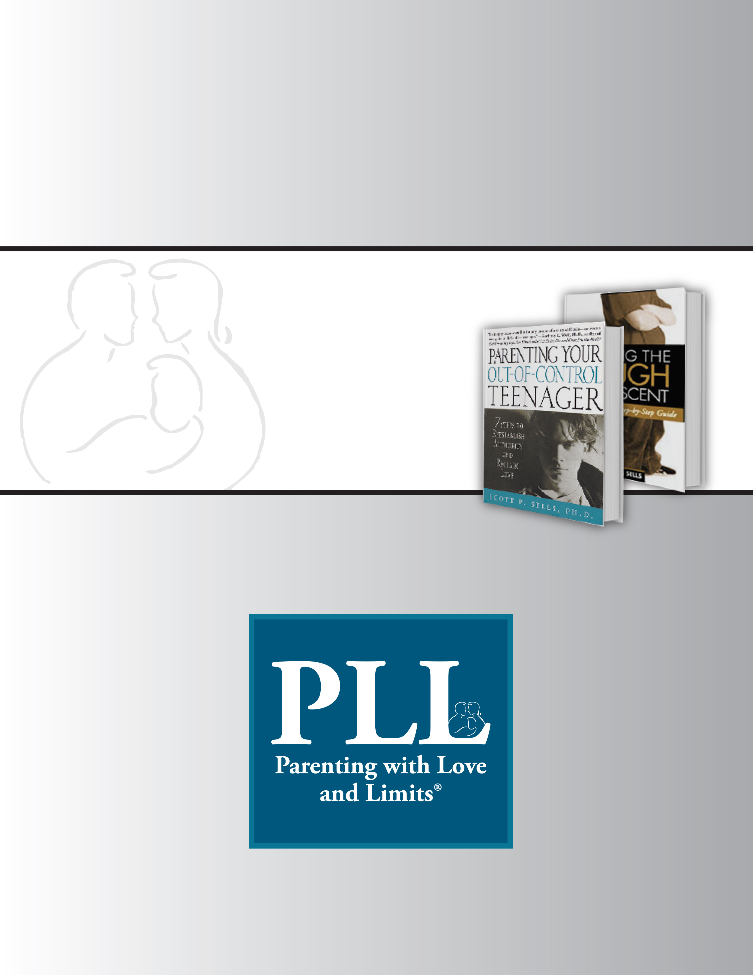

Instructions:
How to complete the Risks/Protective Factors/Needs Document (RPN Document) for CBAT

CBAT- Completing the RPN document

RISKS:

Definition: Risks are negative influences in the lives of individuals or a community. These may increase the presence of crime, victimization or fear of crime in a community and may also increase the likelihood that individuals engage in crime or become victims.

To identify the risks: gather information from the motivational interview, motivational intake, discussions with the PLL therapist, discussions with other service providers (relevant to the family) and individual case management sessions with the family. Use your own experience and judgment to decide which factors CBAT will address.
Target: maximum of 6 risk factors

Categories for Risk Factors:
- Individual factors
  - Early antisocial behavior
  - Emotional factors such as high behavioral activation(sensation seeking, impulsivity, hyperactivity, predatory aggression) and low behavioral inhibition(fearfulness, anxiety, timidity, shyness)
  - Drug/alcohol abuse
  - Poor cognitive development
  - Low intelligence
  - Hyperactivity
- Family factors:
  - Parenting (lack of parental supervision, high level of parent-child conflict, low level of positive involvement/nurturance)
  - Maltreatment
  - Family violence
  - Divorce
  - Parental mental health issues
  - Familial antisocial behaviors
  - Teenage parenthood
  - Family structure (single mother household etc.)
  - Large family size
  - Children of parents in conflict with the law
  - Homelessness
  - Family Isolation (lack of family and/or social support)
- Peer factors
  - Association with negative peers
  - Peer rejection/bullying
  - Gang Involvement
- School and Community factors
  - Failure to bond to school
  - Poor academic performance
  - Low academic aspirations
  - Poverty
  - Neighborhood disadvantage
  - Disorganized neighborhoods
  - Concentration of delinquent peer groups
  - Access to weapons

PROTECTIVE FACTORS

Definition: Protective factors are positive conditions or positive attributes in individuals, families, communities or the larger society that, when present, mitigate or eliminate risk in families or communities.
Protective factors buffer the effects of the risk factors!

Protective factor examples:
- Positive attitudes, values or beliefs
- Conflict resolution skills
- Good mental/physical/spiritual and emotional health
- Positive self-esteem
- Success at school
- Good parenting skills
- Parental supervision
- Strong social supports
- Community engagement
- Problem solving skills
- Positive adult role models, coaches, mentors
- Healthy early childhood development
- Participation in social and cultural activities
- Good peer group/friends
- Steady employment
- Stable housing
- Availability of services (social, recreational, cultural, etc.)

NEEDS

Definition: Interventions to target risk factors and utilize protective factors.
What are the “needs” that you will want the CBAT team to help you fulfill? Mentoring? Community service work? Part-time employment? Tutoring?

Think of these as the actual “Action Steps” to address the risk factors. Information for this section comes from the CBAT meeting team members, your meetings with other social service providers, your own personal/professional knowledge of the area, discussions with the family about resources in their area that they have never contacted etc.

Levels of fulfilling needs:
    - Individual level-conflict resolution classes, resume writing classes, skill building training groups, alcohol/drug prevention classes, organized youth groups
    - Family/Peer level-mentoring programs, structured after school activities,
    - Community/school/workplace level-school based anti-bullying programs, volunteer activities
    - Societal level-school, recreational programs, religious community
    - Concrete Support for Parents-“Village”-friends who are sympathetic listeners/give advice/girls night out/support for contract, housing assistance, health care assistance, financial assistance

Quick Reference Sheet
Risks/Protective Factors/Needs
Document

Youth:______________________________ Age of Youth: ___________________
Risk Factors | Protective Factors | Needs

Notes and CBAT Team Recommendations:

