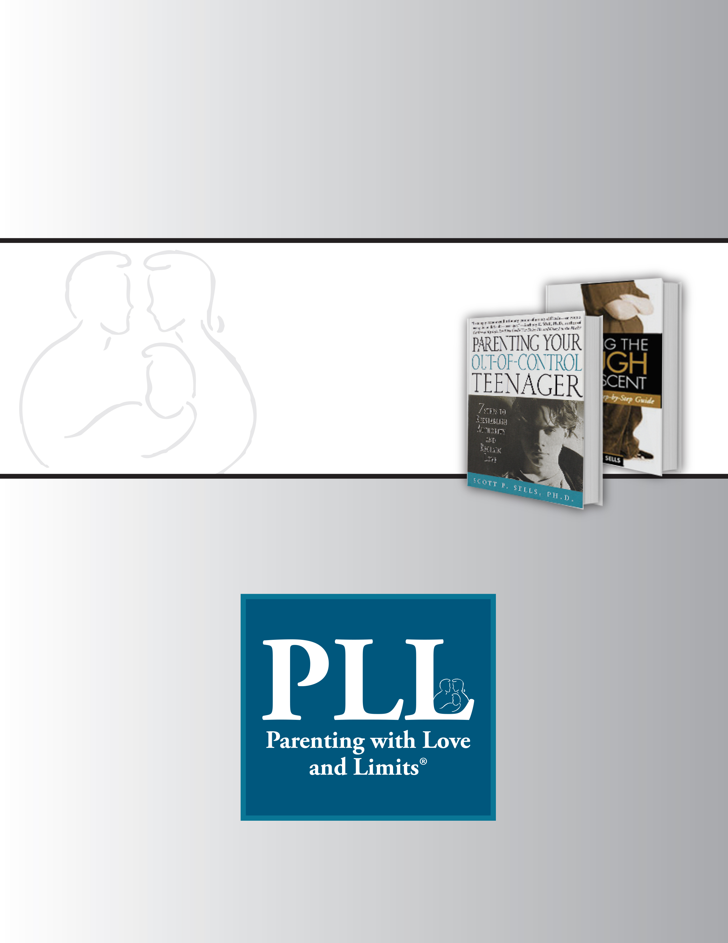

PLL Research Introduction Meeting
Guide


PLL Research Introduction Meeting
Agenda

[SITE]
[DATE]

Purpose of Meeting:
- To introduce PLL Research, Logic Model and Logic Model Research Questions to [Site].
- To gain a better understanding of [Site]’s targeted population.
- To determine the Research Track (Trend Analysis or Quasi Experimental Design).
Attendees: [List PLL Team and Site Team]
Please have available:
- Provided by PLL
  - PLL Logic Model
  - PLL Logic Model Research Questions – Child Welfare, Juvenile Justice, and Community Mental Health
  - PLL Research Track Checklist
- Provided by [Site]
  - Targeted Population
  - Site Locations
----- Agenda Topics -----
PLL Research Introduction Meeting
- Introduction of PLL Team
- Introduction of [Site] Team
- PLL Logic Model Review
- [Site] Targeted Population Discussion
- PLL Logic Model Research Question Review
- PLL Research Track Checklist Review
- Next Steps

PLL Research Introduction Meeting Notes

Meeting called by: |  | Note Taker:
Facilitator:
---------- Agenda Topics ----------
PLL Research Introduction Meeting
 | Discussion:
 | - Introduction of PLL Team
 | - Introduction of [Site] Team
- PLL Logic Model Review – Questions/Concerns
[Type Notes]
- [Site] Targeted Population – Questions/Concerns
[Type Notes]
- PLL Logic Model Research Questions Review – Questions/Concerns
[Type Notes]
- PLL Research Track Checklist Review – What Track is Determined
[Type Notes]
 | Next Steps/Conclusions:
 | Action items: |  | Person responsible: |  | Deadline:

 |  | PLL Research Introduction Meeting  What to Review with Site – Talking Points
---------- Talking Points ----------
Allocated Time for Meeting: 1.5 hours
PLL Research Introduction Meeting
 | Discussion:
- PLL Logic Model Review –
  - Make connections how the PLL Logic Model is an overview of the intervention, outlines the anticipated impact PLL has on their youth and families, and guides the research evaluation. Discuss the framework of the Logic Model - It consists of Target Population (risk factors), Process (activities), Proximal Outcomes (Short-Term), and Distal Outcomes (Long-Term).
  - Discuss how the services are geared toward the targeted population and the proximal and distal outcomes are what behavior changes are expected once a youth and family successfully complete PLL.
  - Discuss that the Logic Model is what is being evaluated in the outcomes research study.
- [Site] Targeted Population – Questions/Concerns
  - Ask the site to explain their targeted population – community mental health, juvenile justice, child welfare?
  - This will help determine what PLL Logic Model research questions are appropriate/answered – Note use the PLL Logic Model Research Questions in Google Doc.
- PLL Logic Model Research Questions Review – Questions/Concerns
  - Based on the targeted population discussion, review the PLL Logic Model Research Questions that are appropriate for their targeted population.
  - Discuss that these are the standard/common research questions that PLL will be answering during the QI study and would be required by the site to provide data on. You do not need to get into data collection requirements at this point, that will be for the next meeting (Logic Model Research Question Development and Approval)
- PLL Research Track Checklist Review – What Track is Determined
  - Review the two tracks with the site.
  - Determine (preliminary) most appropriate track for the site. Determination should be based on the targeted population research question discussion and track checklist – do they meet the full requirements to participate in a full QE study.
- Next Steps
  - For TA Sites only (they only met TA requirements):
    - Have the site sign the Research Track Checklist and send to Clinical Director.
    - Establish process for [site] to provide PLL TA data (See TA Workplan in Google Docs).

  - For QE Sites (Met QE requirements):
    - Provide the site some time to discuss the Tracks internally with their team (a week or so) and get back to the Clinical Director on how they would like to proceed. Note- just because the site meets the requirements for the full QE study they may not want to take on that responsibility at this time. You will want to give them time to discuss it.
    - Once a final agreement is made between the site and PLL as to which track, have the team sign the Research Track Checklist and give to Clinical Director.
      - If the site decides on the QE Study track, schedule the Logic Model Research Question Development and Approval meeting. If the site decides on the TA track conduct next steps as above for TA sites.

Tasks To Prepare for Research Question Development Meeting
(For QE Study Only)

---------- PLL and [Site] ----------
Tasks:
- PLL
  - For TA sites - collect the signed Research Track Checklist
  - For QE sites - Provide time for the site to meet on their own to determine which track is appropriate (for those sites that meet QE requirements only). Set a date when they will have a determination and put that in the notes under action items.
  - Collect the Research Track Checklist.
  - Schedule Next Meeting: Research Question Development and Approval Meeting.
  - After receiving signed Research Track Checklist for QE, send out the appropriate PLL Logic Model Research Questions for review based on their target population for review prior to Research Question Development Meeting.
Note – Use the Logic Model Research Questions in Google Docs.

- Site
  - Meet as a team to determine track (if they met QE requirements).
  - Sign Research Track Checklist and Return to PLL Clinical Director.
  - Once Checklist is signed, review the PLL Logic Model Research Questions (Site will be prepared for Research Question discussion)

